Microservices with Spring Boot 3 and Spring Cloud OUTPUTS
- Creating Microservices for account and loan
Step – 1 : Go to spring initializr and create a maven project.
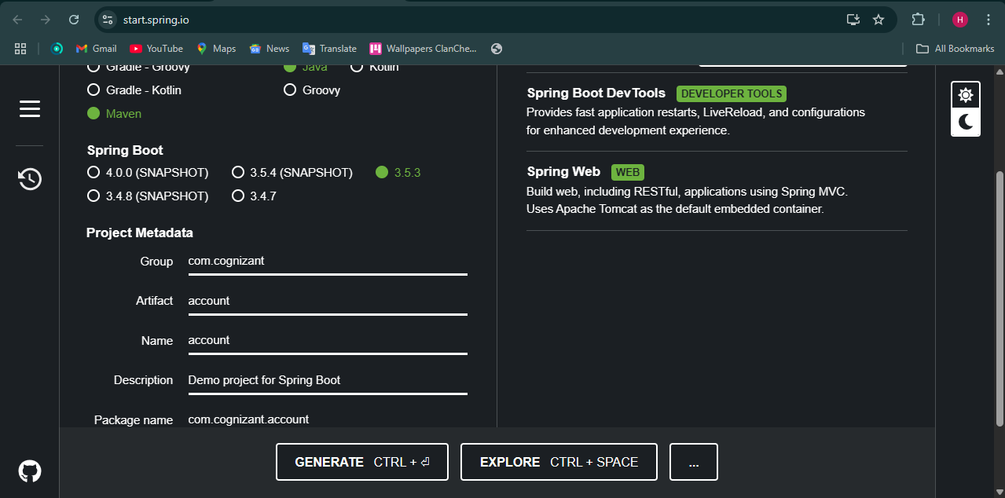
Step – 2 : Import the file in eclipse.
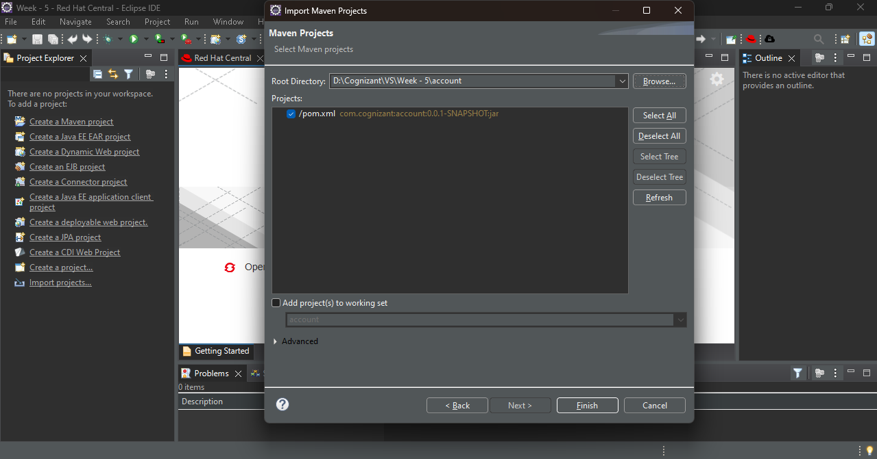
Step – 3 : Create AccountController.java class in com.cognizant.account package.
Code :
package com.cognizant.account;

import org.springframework.web.bind.annotation.*;

@RestController
public class AccountController {

@GetMapping("/accounts/{number}")
public Account getAccountDetails(@PathVariable String number) {
return new Account(number, "savings", 234343);
}
}

class Account {
private String number;
private String type;
private double balance;

public Account(String number, String type, double balance) {
this.number = number;
this.type = type;
this.balance = balance;
}

public String getNumber() { return number; }
public String getType() { return type; }
public double getBalance() { return balance; }
}
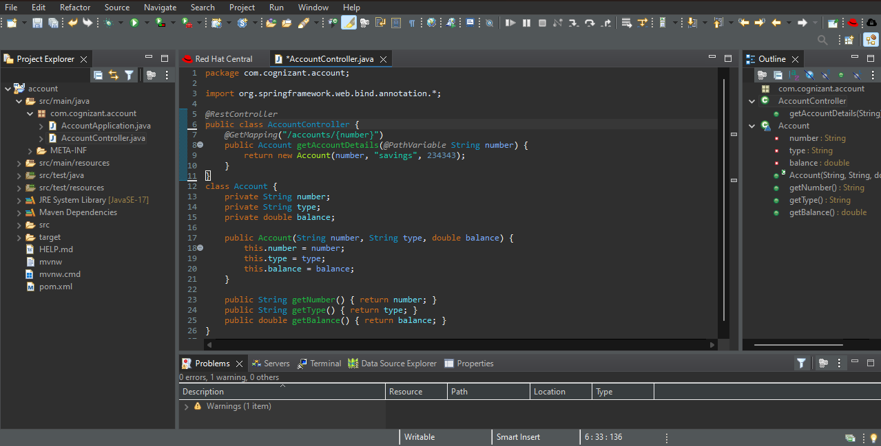

Step – 4 : Now go to spring initializr and create a another project loans.
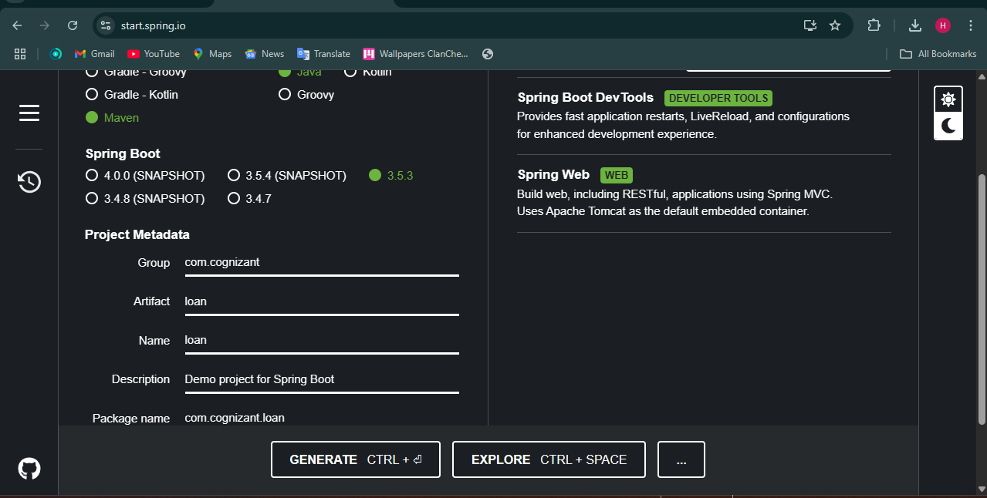

Step – 5 : Import the project in eclipse.
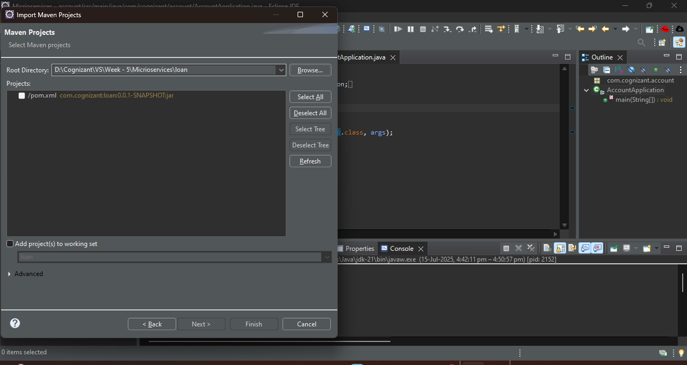

Step – 6 : Go to src/main/resources/application.properties and enter our port number.
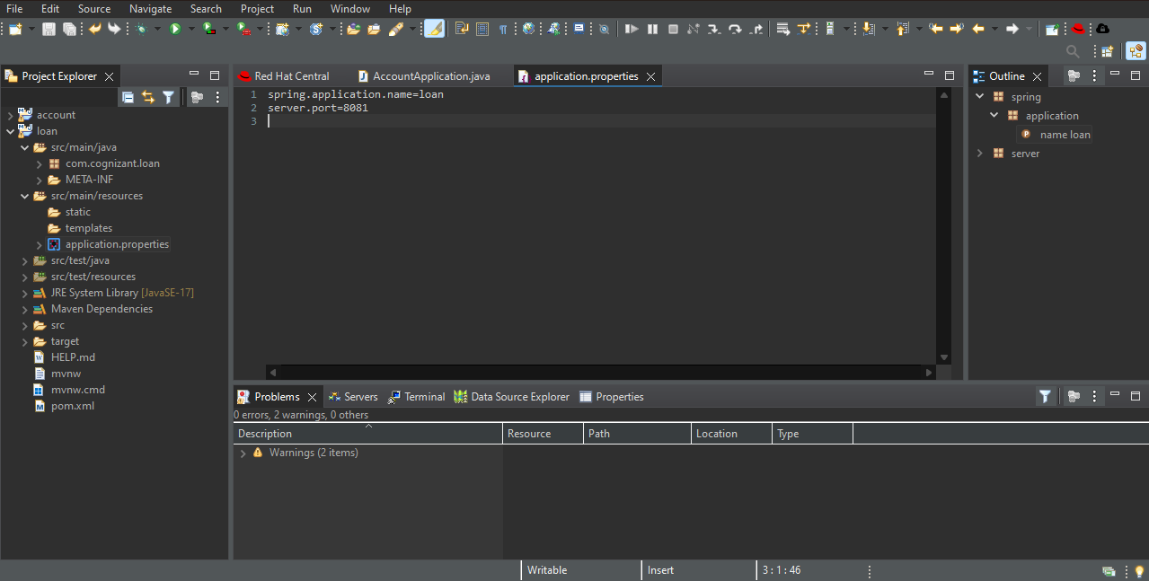

Step – 7 : Create LoanController.java in com.cognizant.loan package.
Code :
package com.cognizant.loan;

import org.springframework.web.bind.annotation.*;

@RestController
public class LoanController {

@GetMapping("/loans/{number}")
public Loan getLoanDetails(@PathVariable String number) {
return new Loan(number, "car", 400000, 3258, 18);
}
}

class Loan {
private String number;
private String type;
private double loan;
private int emi;
private int tenure;

public Loan(String number, String type, double loan, int emi, int tenure) {
this.number = number;
this.type = type;
this.loan = loan;
this.emi = emi;
this.tenure = tenure;
}

public String getNumber() { return number; }
public String getType() { return type; }
public double getLoan() { return loan; }
public int getEmi() { return emi; }
public int getTenure() { return tenure; }
}
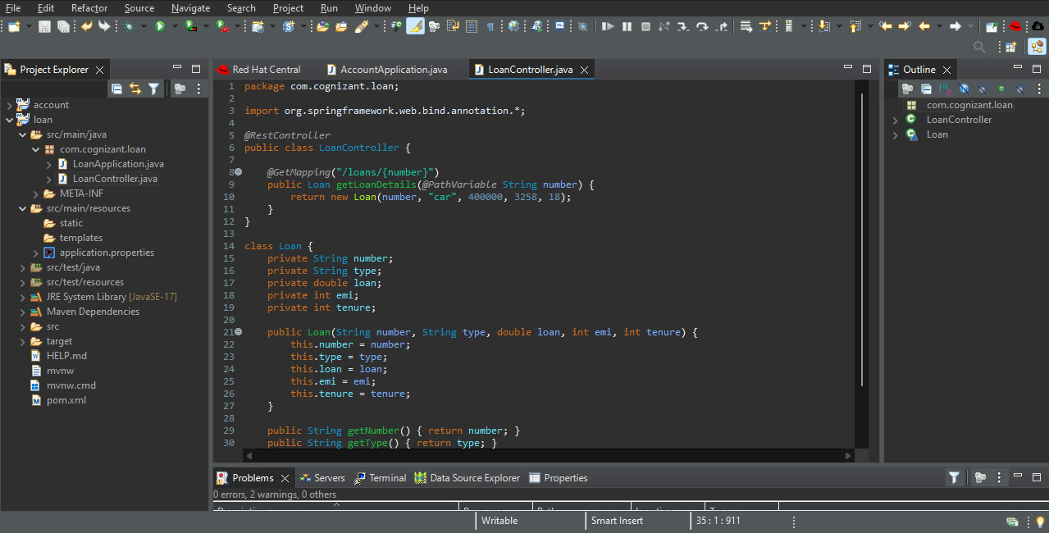

Step – 8 : Run LoanApplication.java as java application.
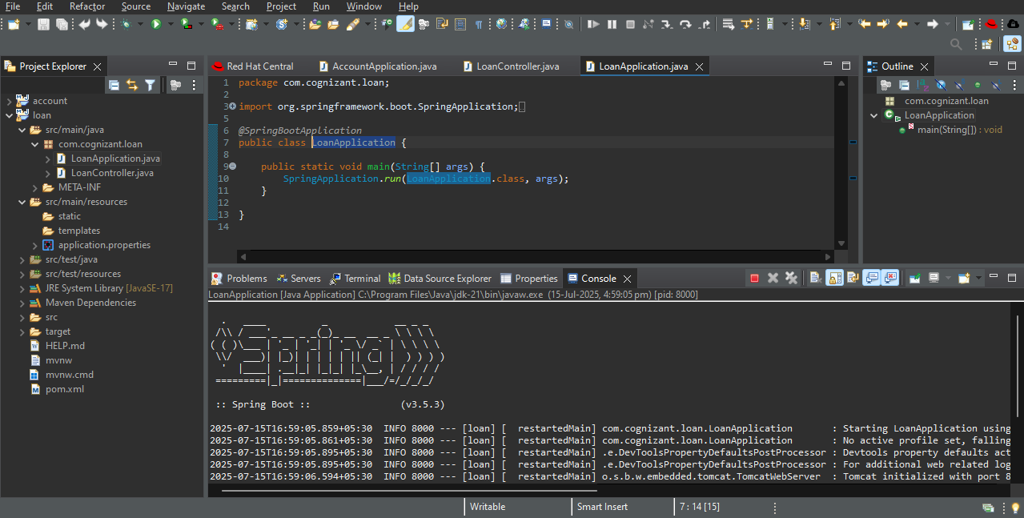

Step – 9 : Go to AccountApplication.java and run it as java application.
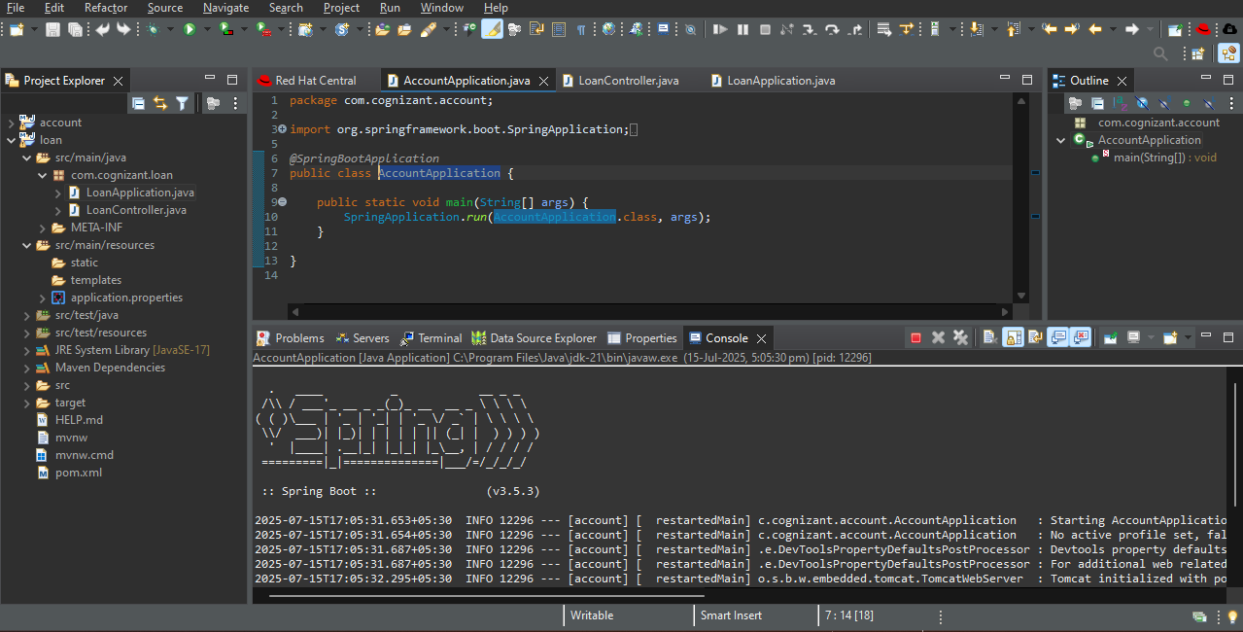
Step – 10 : Go to postman and run
- http://localhost:8080/accounts/00987987973432
- http://localhost:8081/loans/H00987987972342
Make sure you enter different port numbers for both applications.

OUTPUT :
1. 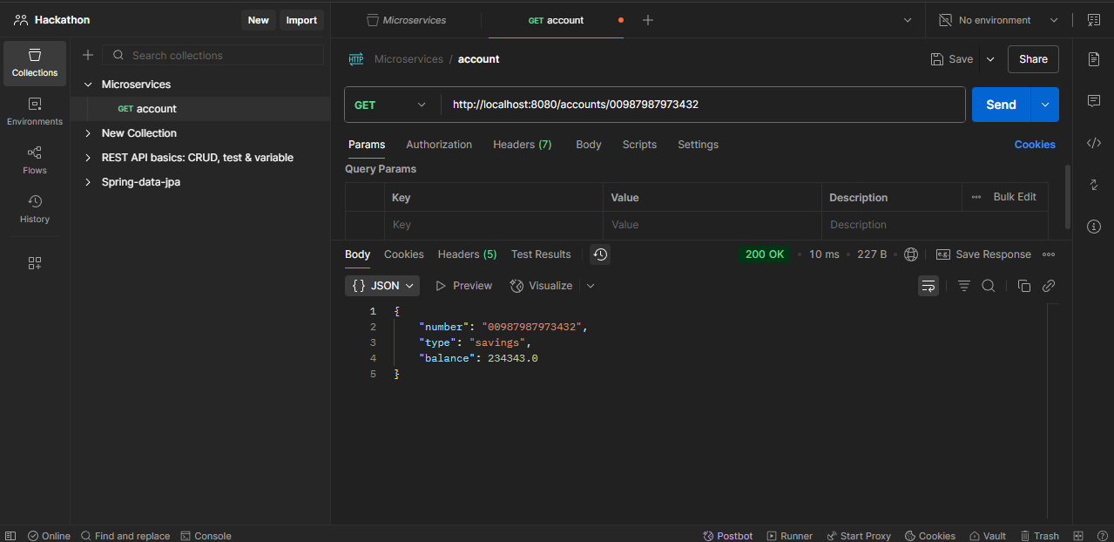

2.
